Cruise Plan

14 August 2007
10:00 Liquid Nitrogen safety meeting
10:00 Leave Dock
11:30 Finish Safety Drills, travel to NH-10, begin mooring deployment
15:00 Finish mooring deployment; conduct a few CTD casts with some training; conduct a coring operation with some training.
18:00 Begin monitoring and testing of OSU-WET Labs profiler mooring (deployed previous week). Recover and redeploy if necessary.
15 August 2007
06:00 Return to dock at Newport; scientific crew change
08:00 Leave Dock and Transit to station SH-10
10:30 Begin Strawberry Hill transect (CTD at 9 stations, Niskin bottles at 5 stations)
21:00 Transit to station LB-100
16 August 2007
02:00 Begin Lincoln Beach transect (CTD at 8 stations)
06:00 Transit to station NH-1
08:30 Begin Newport Line transect (CTD at 10 stations, Niskin bottles at 5 stations)
18:30 Transit to station CH-25
22:30 Begin Cascade Head transect (CTD at 8 stations)
17 August 2007
03:30 Transit to station CM-1
07:30 Begin Cape Meares transect (CTD at 10 stations, Niskin bottles at 5 stations)
19:00 Transit to station CF-30
22:30 Begin Cape Falcon transect (CTD at 8 stations)
18 August 2007
04:30 Transit to station CR-4
07:00 Begin daytime Columbia River transect (CTD at 10 stations, Niskin bottles at 5 stations)
20:00 Begin nighttime Columbia River transect (CTD at 10 stations)
19 August 2007
06:30 Transit to Astoria
08:00 Dock in Astoria; scientific crew change, transfer of frozen samples.
12:00 Transit to station CR-4
13:30 Begin Neap Tide Columbia River Plume transects
20 August 2007
Continue Neap Tide Columbia River Plume transects
21 August 2007
03:30 Transit to station WB-5
07:00 Begin Willipa Bay transect (CTD at 8 stations, Niskin bottles at 5 stations)
17:30 Transit to station GH-36
19:30 Begin Gray’s Harbor transect (CTD at 8 stations)
22 August 2007
02:00 Transit to station LP-4
08:30 Begin La Push transect (CTD at 10 stations, Niskin bottles at 5 stations)
20:30 Transit to station QR-29
19:30 Begin Queet’s River transect (CTD at 7 stations)
23 August 2007
06:00 Transit to Astoria
14:00 Dock in Astoria; scientific crew change, transfer of frozen samples.
24 August 2007
25 August 2007
26 August 2007
04:00 Transit to Estuary South Channel Station
06:00 Begin transects along salinity gradient in South Channel
27 August 2007
04:00 Transit to Estuary Mouth ETM Station
06:00 Begin transects along salinity gradient at Estuary Mouth
28 August 2007
04:00 Transit to Estuary North Channel Station
06:00 Begin transects along salinity gradient in North Channel
29 August 2007
04:00 Transit to station CR-4
06:00 Begin Spring Tide Columbia River Plume transects
30 August 2007
21:00 Transit to Newport
31 August 2007
07:00 Offload ship
1 September 2007

Sampling locations

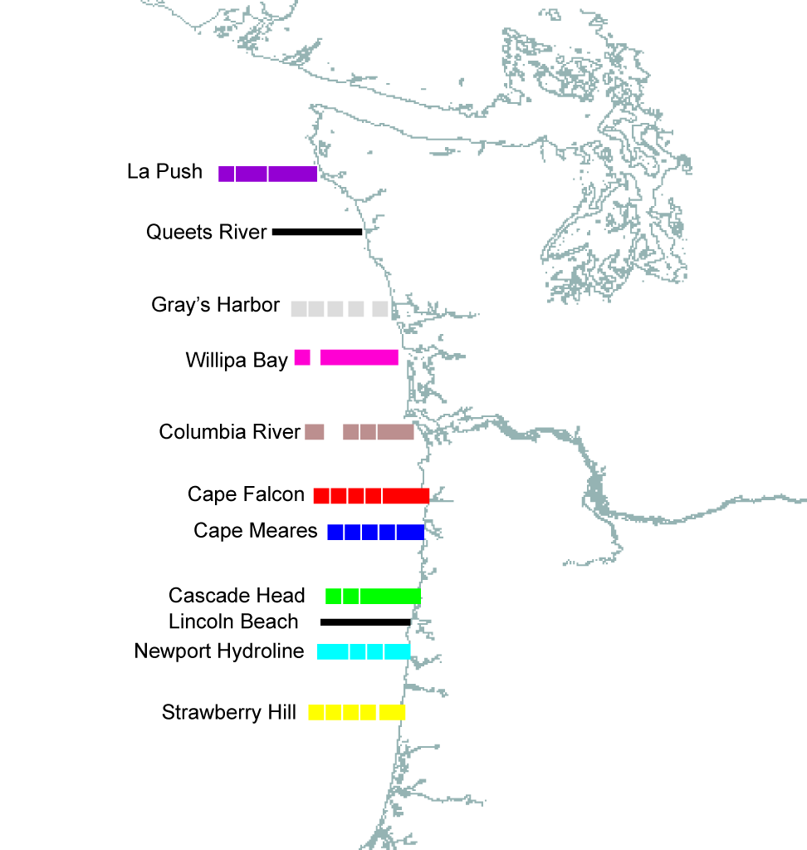

Station Table
Note that water sampling will occur at approximately 5 stations on each coastal transect line. Location of these stations will be determined in the weeks preceding the cruise.

Date | Station | Longitude | Latitude
14-Aug-07 | Newport, Oregon | 44 deg 37.50' | 124 deg 2.60'
14-Aug-07 | NH-10 | 44 deg 39.10' | 124 deg 17.70'
15-Aug-07 | Newport, Oregon | 44 deg 37.50' | 124 deg 2.60'
15-Aug-07 | SH-10 | 44 deg 15.10' | 124 deg 7.39'
15-Aug-07 | SH-15 | 44 deg 15.10' | 124 deg 7.64'
15-Aug-07 | SH-30 | 44 deg 15.10' | 124 deg 8.04'
15-Aug-07 | SH-40 | 44 deg 15.10' | 124 deg 9.00'
15-Aug-07 | SH-50 | 44 deg 15.10' | 124 deg 10.12'
15-Aug-07 | SH-70 | 44 deg 15.10' | 124 deg 15.13'
15-Aug-07 | SH-90 | 44 deg 15.10' | 124 deg 23.51'
15-Aug-07 | SH-100 | 44 deg 15.10' | 124 deg 27.70'
15-Aug-07 | SH-f | 44 deg 15.10' | 125 deg 9.52'
16-Aug-07 | LB-100 | 44 deg 51.50' | 124 deg 12.25'
16-Aug-07 | LB-90 | 44 deg 51.50' | 124 deg 10.87'
16-Aug-07 | LB-80 | 44 deg 51.50' | 124 deg 10.11'
16-Aug-07 | LB-70 | 44 deg 51.50' | 124 deg 9.27'
16-Aug-07 | LB-60 | 44 deg 51.50' | 124 deg 6.96'
16-Aug-07 | LB-70 | 44 deg 51.50' | 124 deg 9.27'
16-Aug-07 | LB-80 | 44 deg 51.50' | 124 deg 10.11'
16-Aug-07 | LB-90 | 44 deg 51.50' | 124 deg 10.87'
16-Aug-07 | NH-1 | 44 deg 39.10' | 124 deg 6.00'
16-Aug-07 | NH-3 | 44 deg 39.10' | 124 deg 7.80'
16-Aug-07 | NH-5 | 44 deg 39.10' | 124 deg 10.60'
16-Aug-07 | NH-10 | 44 deg 39.10' | 124 deg 17.70'
16-Aug-07 | NH-15 | 44 deg 39.10' | 124 deg 24.70'
16-Aug-07 | NH-20 | 44 deg 39.10' | 124 deg 31.70'
16-Aug-07 | NH-25 | 44 deg 39.10' | 124 deg 39.00'
16-Aug-07 | NH-35 | 44 deg 39.10' | 124 deg 53.00'
16-Aug-07 | NH-45 | 44 deg 39.10' | 125 deg 7.00'
16-Aug-07 | NH-55 | 44 deg 39.10' | 125 deg 22.00'
16-Aug-07 | CH-25 | 45 deg 3.00' | 124 deg 34.30'
16-Aug-07 | CH-20 | 45 deg 3.00' | 124 deg 27.50'
17-Aug-07 | CH-15 | 45 deg 3.00' | 124 deg 20.50'
17-Aug-07 | CH-10 | 45 deg 3.00' | 124 deg 14.00'
17-Aug-07 | CH-5 | 45 deg 3.00' | 124 deg 8.00'
17-Aug-07 | CH-2 | 45 deg 3.00' | 124 deg 4.50'
17-Aug-07 | CH-1 | 45 deg 3.00' | 124 deg 2.00'
17-Aug-07 | CM-1 | 45 deg 29.00' | 124 deg 0.40'
17-Aug-07 | CM-3 | 45 deg 29.00' | 124 deg 2.20'
17-Aug-07 | CM-5 | 45 deg 29.00' | 124 deg 5.50'
17-Aug-07 | CM-10 | 45 deg 29.00' | 124 deg 12.50'
17-Aug-07 | CM-15 | 45 deg 29.00' | 124 deg 19.60'
17-Aug-07 | CM-20 | 45 deg 29.00' | 124 deg 26.90'
17-Aug-07 | CM-25 | 45 deg 29.00' | 124 deg 33.60'
17-Aug-07 | CM-30 | 45 deg 29.00' | 124 deg 40.80'
17-Aug-07 | CM-a | 45 deg 29.00' | 124 deg 55.04'
17-Aug-07 | CM-b | 45 deg 29.00' | 125 deg 9.20'
17-Aug-07 | CF-30 | 45 deg 44.00' | 124 deg 39.00'
17-Aug-07 | CF-25 | 45 deg 44.00' | 124 deg 32.00'
18-Aug-07 | CF-20 | 45 deg 44.00' | 124 deg 25.00'
18-Aug-07 | CF-15 | 45 deg 44.00' | 124 deg 18.00'
18-Aug-07 | CF-10 | 45 deg 44.00' | 124 deg 11.10'
18-Aug-07 | CF-7 | 45 deg 44.00' | 124 deg 6.90'
18-Aug-07 | CF-3 | 45 deg 44.00' | 124 deg 1.50'
18-Aug-07 | CF-1 | 45 deg 44.00' | 123 deg 58.50'
18-Aug-07 | CR-4 | 46 deg 10.00' | 124 deg 4.60'
18-Aug-07 | CR-7 | 46 deg 10.00' | 124 deg 9.50'
18-Aug-07 | CR-10 | 46 deg 10.00' | 124 deg 13.10'
18-Aug-07 | CR-15 | 46 deg 10.00' | 124 deg 20.00'
18-Aug-07 | CR-20 | 46 deg 10.00' | 124 deg 27.10'
18-Aug-07 | CR-25 | 46 deg 10.00' | 124 deg 33.40'
18-Aug-07 | CR-30 | 46 deg 10.00' | 124 deg 40.20'
18-Aug-07 | CR-35 | 46 deg 10.00' | 124 deg 47.50'
18-Aug-07 | CR-40 | 46 deg 10.00' | 124 deg 54.60'
18-Aug-07 | CR-50 | 46 deg 10.00' | 125 deg 1.80'
18-Aug-07 | CR-50 | 46 deg 10.00' | 125 deg 1.80'
18-Aug-07 | CR-40 | 46 deg 10.00' | 124 deg 54.60'
18-Aug-07 | CR-35 | 46 deg 10.00' | 124 deg 47.50'
19-Aug-07 | CR-30 | 46 deg 10.00' | 124 deg 40.20'
19-Aug-07 | CR-25 | 46 deg 10.00' | 124 deg 33.40'
19-Aug-07 | CR-20 | 46 deg 10.00' | 124 deg 27.10'
19-Aug-07 | CR-15 | 46 deg 10.00' | 124 deg 20.00'
19-Aug-07 | CR-10 | 46 deg 10.00' | 124 deg 13.10'
19-Aug-07 | CR-7 | 46 deg 10.00' | 124 deg 9.50'
19-Aug-07 | CR-4 | 46 deg 10.00' | 124 deg 4.60'
19-Aug-07 | Astoria, Oregon | 46 deg 12.50' | 123 deg 46.00'
19-Aug-07 | Columbia R. Plume
20-Aug-07 | Columbia R. Plume
21-Aug-07 | Columbia R. Plume
21-Aug-07 | WB-5 | 46 deg 40.00' | 124 deg 11.00'
21-Aug-07 | WB-9 | 46 deg 40.00' | 124 deg 17.50'
21-Aug-07 | WB-14 | 46 deg 40.00' | 124 deg 24.00'
21-Aug-07 | WB-19 | 46 deg 40.00' | 124 deg 30.50'
21-Aug-07 | WB-23 | 46 deg 40.00' | 124 deg 36.50'
21-Aug-07 | WB-30 | 46 deg 40.00' | 124 deg 47.00'
21-Aug-07 | WB-40 | 46 deg 40.00' | 125 deg 1.50'
21-Aug-07 | WB-50 | 46 deg 40.00' | 125 deg 16.02'
21-Aug-07 | GH-36 | 47 deg 0.00' | 125 deg 3.70'
21-Aug-07 | GH-31 | 47 deg 0.00' | 124 deg 56.40'
21-Aug-07 | GH-26 | 47 deg 0.00' | 124 deg 48.80'
21-Aug-07 | GH-21 | 47 deg 0.00' | 124 deg 41.70'
21-Aug-07 | GH-16 | 47 deg 0.00' | 124 deg 33.50'
22-Aug-07 | GH-10 | 47 deg 0.00' | 124 deg 25.00'
22-Aug-07 | GH-6 | 47 deg 0.00' | 124 deg 19.20'
22-Aug-07 | GH-3 | 47 deg 0.00' | 124 deg 14.80'
22-Aug-07 | LP-4 | 47 deg 55.00' | 124 deg 44.50'
22-Aug-07 | LP-6 | 47 deg 55.00' | 124 deg 47.50'
22-Aug-07 | LP-9 | 47 deg 55.00' | 124 deg 52.50'
22-Aug-07 | LP-12 | 47 deg 55.00' | 124 deg 57.50'
22-Aug-07 | LP-17 | 47 deg 55.00' | 125 deg 5.00'
22-Aug-07 | LP-22 | 47 deg 55.00' | 125 deg 11.50'
22-Aug-07 | LP-27 | 47 deg 55.00' | 125 deg 18.50'
22-Aug-07 | LP-32 | 47 deg 55.00' | 125 deg 25.94'
22-Aug-07 | LP-42 | 47 deg 55.00' | 125 deg 40.82'
22-Aug-07 | LP-52 | 47 deg 55.00' | 125 deg 55.70'
23-Aug-07 | QR-29 | 47 deg 32.00' | 125 deg 3.50'
23-Aug-07 | QR-24 | 47 deg 32.00' | 124 deg 56.00'
23-Aug-07 | QR-19 | 47 deg 32.00' | 124 deg 48.50'
23-Aug-07 | QR-14 | 47 deg 32.00' | 124 deg 42.00'
23-Aug-07 | QR-10 | 47 deg 32.00' | 124 deg 36.50'
23-Aug-07 | QR-6 | 47 deg 32.00' | 124 deg 30.00'
23-Aug-07 | QR-3 | 47 deg 32.00' | 124 deg 25.50'
23-Aug-07 | Astoria, Oregon | 46 deg 12.50' | 123 deg 46.00'
 | To be decided
26-Aug-07 | Columbia River estuary
27-Aug-07 | Columbia River estuary
28-Aug-07 | Columbia River estuary
29-Aug-07 | Columbia R. Plume
30-Aug-07 | Columbia R. Plume
31-Aug-07 | Newport, Oregon | 44 deg 37.50' | 124 deg 2.60'

Summary of Operations Diagram

